Title: Multimodal AI Framework for Real-Time Pharmaceutical Quality Assurance using Object Detection, OCR, and Generative Language Models
ABSTRACT
This research presents the design and implementation of MedSecure (MedMitra), an AI-driven real-time pharmaceutical quality inspection system that integrates computer vision, optical character recognition (OCR), and generative artificial intelligence for automated medicine verification. Ensuring the safety and authenticity of medicines is critical in modern healthcare, as improper storage, physical damage, counterfeit products, and expired medicines can pose serious health risks. Traditional inspection methods rely on manual verification, which is slow, error-prone, and difficult to scale for large inventories. The proposed system uses a three-tier architecture consisting of a React frontend, Node.js backend, and FastAPI-based AI microservice. The AI layer combines YOLOv8 object detection for identifying packaging defects, Tesseract OCR for extracting batch and expiry information, and Google Gemini multimodal AI for contextual reasoning and safety evaluation. Image preprocessing techniques are applied to improve text recognition accuracy, and inspection results are stored in a database and log file for traceability. Experimental evaluation shows that the system can perform real-time inspection on standard CPU hardware while providing meaningful explanations through generative AI. The framework demonstrates how modern AI technologies can be integrated to create a scalable pharmaceutical quality assurance system suitable for hospitals, pharmacies, and supply chains, with future scope including edge deployment, blockchain tracking, multilingual OCR, and mobile integration.

CHAPTER 1
INTRODUCTION
1.1 Background
The pharmaceutical industry plays a critical role in ensuring public health by delivering safe and effective medicines to patients. However, the global medicine supply chain faces several challenges including counterfeit products, improper storage, damaged packaging, and expired medicines. According to reports from international health organizations, a significant percentage of medicines distributed in developing countries fail quality standards due to handling errors or lack of proper inspection.
Recent advancements in artificial intelligence and deep learning have enabled automated inspection systems capable of performing complex visual analysis with high accuracy. Convolutional neural networks have shown excellent performance in image classification and object detection tasks [4],[6],[8],[21]. Real-time object detection algorithms such as YOLO allow fast and accurate detection, making them suitable for live inspection systems [1], [2].
Optical Character Recognition is commonly used to extract printed information from labels and packaging [3], [7]. Modern multimodal artificial intelligence models can analyze images together with text and generate contextual explanations, which is useful in medical decision support systems [11], [12].
In pharmaceutical supply chains, quality verification is essential to prevent distribution of expired or damaged medicines. Reports from the World Health Organization indicate that a significant percentage of medicines fail quality standards due to improper handling and storage [16]. Automated inspection systems can reduce human error and improve reliability.
In pharmaceutical supply chains, quality inspection is essential to prevent distribution of expired or damaged medicines. Reports from the World Health Organization indicate that a significant percentage of medicines in developing countries fail quality standards due to poor storage and lack of verification mechanisms [14]. Automated inspection systems can reduce human error and improve reliability in such scenarios [26].
Traditional quality inspection methods are mostly manual and depend on trained personnel to visually check packaging, expiry dates, and batch numbers. These methods are slow, inconsistent, and difficult to scale. With the increase in online pharmacies, decentralized storage, and automated warehouses, there is a need for intelligent inspection systems capable of performing fast and reliable quality checks.
This research introduces MedSecure (MedMitra), an AI-based medicine inspection system that combines object detection, OCR, and generative AI to provide real-time quality evaluation.

1.2 Problem Statement
Traditional inspection methods rely on manual checking, which is time-consuming and prone to human error. Deep learning-based inspection systems provide more reliable results compared to rule-based methods [4], [19]. Combining object detection, OCR, and generative AI allows automated verification of medicine quality in real time [1], [3], [11].
Manual medicine inspection has several limitations:
- Human error during visual verification
- Difficulty in reading faded labels
- Lack of real-time automated validation
- No contextual reasoning about safety
- No digital log for audit tracking
Traditional inspection methods rely on manual checking, which is time-consuming and inconsistent. Computer vision systems combined with OCR and artificial intelligence provide a scalable solution for automated verification [6], [8]. Recent developments in multimodal AI allow systems to analyze both images and text to generate meaningful conclusions, which is useful in medical decision support applications [5], [9], [18]. Therefore, a system is required that can:
- Detect medicine packaging condition
- Extract expiry date and batch number
- Analyze safety using AI reasoning
- Store inspection results
- Work in real time

1.3 Aim and Objectives
The aim of this research is to develop an AI-driven medicine inspection system capable of real-time quality verification.
Objectives:
- Implement YOLOv8 for damage detection
- Implement OCR for text extraction
- Integrate Generative AI for reasoning
- Build web-based interface
- Store inspection logs
- Generate automatic quality reports

1.4 Thesis Layout
This thesis is divided into six chapters.
Chapter 1 describes the introduction and problem statement.
Chapter 2 presents literature review of AI, OCR, and object detection.
Chapter 3 explains system architecture and methodology.
Chapter 4 shows results and screenshots.
Chapter 5 discusses findings.
Chapter 6 gives summary and future work.

CHAPTER 2
LITERATURE REVIEW
2.1 Computer Vision in Healthcare
Computer vision has become an essential component in modern healthcare automation systems. Earlier image processing techniques relied on template matching and rule-based algorithms, which were limited in their ability to handle variations in lighting, orientation, and noise. With the advancement of machine learning, convolutional neural networks (CNN) have become the dominant approach for image classification and object detection tasks. CNN-based models automatically learn hierarchical features from images, allowing them to perform complex recognition tasks with high accuracy [4], [6], [8].
In medical applications, computer vision has been widely used for disease detection, medical imaging analysis, and quality inspection of pharmaceutical products. Automated inspection systems reduce human error and improve reliability in environments where manual verification is difficult. Research shows that deep learning models outperform traditional image processing techniques in defect detection and classification tasks [5], [19].
Real-time object detection has become possible with the introduction of single-stage detectors such as YOLO, which can detect multiple objects in a single pass through the neural network [1],[22]. These models are suitable for applications where speed is critical, such as live monitoring and quality inspection systems. The ability to perform fast and accurate detection makes computer vision an ideal choice for pharmaceutical packaging verification.
Ensuring the safety of medicines is a critical requirement in healthcare systems. According to reports from the World Health Organization, a significant number of medicines fail quality standards due to improper storage, handling, or labeling errors [16]. Automated computer vision systems can help identify such problems before the medicines reach the consumer.

2.2 YOLO Object Detection Models
Object detection is one of the most important tasks in computer vision. Traditional detection algorithms such as Faster-RCNN use region proposal methods, which provide good accuracy but require high computation time[23]. The YOLO (You Only Look Once) algorithm introduced a single-stage detection framework that predicts bounding boxes and class probabilities simultaneously, allowing real-time performance [1], [17], [22].
The YOLO architecture divides the image into grids and predicts object locations in one forward pass of the neural network. This design significantly reduces computation cost while maintaining high accuracy. The latest versions of YOLO, including YOLOv8, provide improved feature extraction and better performance on small objects [2].
Single-stage detectors such as SSD also provide high speed and accuracy for object detection tasks and are commonly used in industrial automation systems [18]. Compared to traditional methods, deep learning-based detectors are more robust to noise, background variations, and lighting changes.
YOLO has been successfully applied in several domains including:
- Medical imaging
- Industrial defect detection
- Surveillance systems
- Autonomous vehicles
- Retail monitoring
The advantages of YOLO include:
- Real-time performance
- High detection accuracy
- Low computational cost
- Ability to run on CPU or edge devices
Due to these advantages, YOLOv8 nano model is used in this research to perform real-time inspection of medicine packaging.

2.3 Optical Character Recognition in Medicine
Optical Character Recognition (OCR) is widely used for extracting printed text from images. OCR technology plays an important role in automated inspection systems where information such as expiry date, batch number, and manufacturing details must be read from product labels. Tesseract OCR is one of the most widely used open-source OCR engines and provides good accuracy when combined with image preprocessing techniques [3].
Image preprocessing is necessary because medicine packaging often contains reflective foil, curved surfaces, and small fonts. These conditions make text extraction difficult using raw images. Techniques such as grayscale conversion, thresholding, and noise filtering improve OCR performance significantly [7].
In pharmaceutical inspection, OCR can be used to automatically verify regulatory information without manual reading. This reduces human error and ensures that expired or incorrectly labeled medicines are not used. Quality assurance guidelines recommend automatic verification systems for maintaining safety in pharmaceutical supply chains [20].
However, OCR in medicine packaging presents several challenges:
- Shiny foil packaging
- Curved labels
- Low lighting conditions
- Motion blur from webcam
To overcome these issues, preprocessing steps such as adaptive thresholding, sharpening, and contrast enhancement are applied before performing OCR.

2.4 Generative AI in Medical Systems
Recent developments in artificial intelligence have introduced large language models capable of performing reasoning tasks. Models such as GPT-4 and Gemini are multimodal systems that can process both text and images to generate meaningful explanations [11], [12]. These models are widely used in decision support systems, automated documentation, and intelligent assistants.
In medical systems, generative AI can be used to analyze data and produce human-readable reports. Instead of only detecting objects, the system can explain why a particular medicine may be unsafe. This ability improves interpretability and makes the system easier to use for non-technical users.
Applications of generative AI in healthcare include:
- Medical report generation
- Clinical decision support
- Chatbot systems
- Image interpretation
- Automated documentation
Multimodal models allow contextual reasoning by combining visual input with textual information. This capability is important in medicine inspection, where both packaging condition and printed information must be analyzed together.

2.5 Research Gap
Existing inspection systems often use only one type of model, which limits their capability.
System | Limitation
OCR only | Cannot detect physical damage
Vision only | Cannot read text
LLM only | Cannot detect objects
Manual inspection | Slow and error-prone
Most existing systems do not combine computer vision, OCR, and generative AI in a single framework. In addition, many systems do not store inspection results for future verification.
Therefore, there is a need for a hybrid system that can:
- Detect objects using deep learning
- Extract text using OCR
- Generate reasoning using AI
- Store inspection logs
- Work in real time
The proposed system addresses these limitations.

2.6 Deep Learning for Packaging Inspection
Deep learning has become the standard approach for quality inspection in industrial applications. Convolutional neural networks are capable of learning complex features from images, allowing accurate detection of defects that are difficult to identify manually [5], [6].
Traditional image processing methods relied on edge detection and color thresholding. These methods fail when the lighting condition changes or when the object orientation varies. Deep learning models overcome this limitation by learning features automatically from training data [8].
Recent research shows that YOLO-based systems achieve high accuracy in detecting defects in manufacturing and packaging industries [19]. These models can detect cracks, missing components, and incorrect labels in real time.
In pharmaceutical inspection, deep learning can be used to detect:
- Broken blister packs
- Torn foil
- Missing tablets
- Damaged boxes
Such automated systems improve reliability and reduce manual effort.

2.7 Multimodal AI and Generative Models
Multimodal artificial intelligence combines information from different sources such as images and text to perform reasoning tasks. Large language models have recently shown the ability to understand visual input and generate natural language explanations [11].
Models such as Gemini and GPT-4 allow contextual understanding, which makes them suitable for decision support systems [12]. These models can analyze both object detection results and OCR text to produce a meaningful report.
In medicine inspection, multimodal AI can:
- Understand packaging condition
- Read expiry date
- Check safety rules
- Generate inspection report
Compared to rule-based systems, generative AI provides more flexible and intelligent analysis.

2.8 OCR in Pharmaceutical Industry
OCR technology is widely used in pharmaceutical industries for label verification and documentation. Automatic text extraction helps ensure that medicines meet regulatory standards [3].
Preprocessing plays a critical role in OCR accuracy. Techniques such as adaptive thresholding, noise removal, and sharpening improve recognition performance [7].
Common problems in pharmaceutical OCR include:
- Reflection on foil
- Curved surface
- Small fonts
- Low resolution images
To overcome these problems, advanced preprocessing methods are applied before performing OCR.
Automatic verification of expiry date and batch number is essential for quality assurance in medicine supply chains [20].

2.9 Web-Based AI Systems
Modern AI systems are often deployed as web applications to allow easy access from different devices. A three-tier architecture consisting of frontend, backend, and AI service layer is commonly used for scalable systems [13], [14].
In such architecture:
- Frontend handles user interface
- Backend manages database and logic
- AI service performs inference
Node.js is widely used for backend development due to its asynchronous architecture, while FastAPI provides high-performance APIs for machine learning models [13], [14]. OpenCV is used for image preprocessing before detection [15].
Advantages of web-based AI systems:
- No installation required
- Easy updates
- Centralized processing
- Supports database logging
This architecture is used in the proposed system.

2.10 Research Gap Analysis
From the literature, the following gaps are observed:
Method | Problem
Manual inspection | Slow
OCR only | No reasoning
CNN only | No text
LLM only | No detection
Existing apps | No logging
The proposed system combines:
- YOLO for detection
- OCR for text extraction
- Generative AI for reasoning
- Web architecture for deployment
- Database for logging
This combination provides a complete solution for real-time medicine quality inspection.

CHAPTER 3
METHODOLOGY
3.1 Overview of Proposed System
The proposed system MedSecure is designed to perform automatic inspection of medicines using computer vision and generative AI. The system captures an image from a webcam, processes it using deep learning models, extracts text using OCR, and generates a quality report using generative AI.
The system follows a three-tier architecture consisting of frontend, backend, and AI service.
The workflow is shown below.
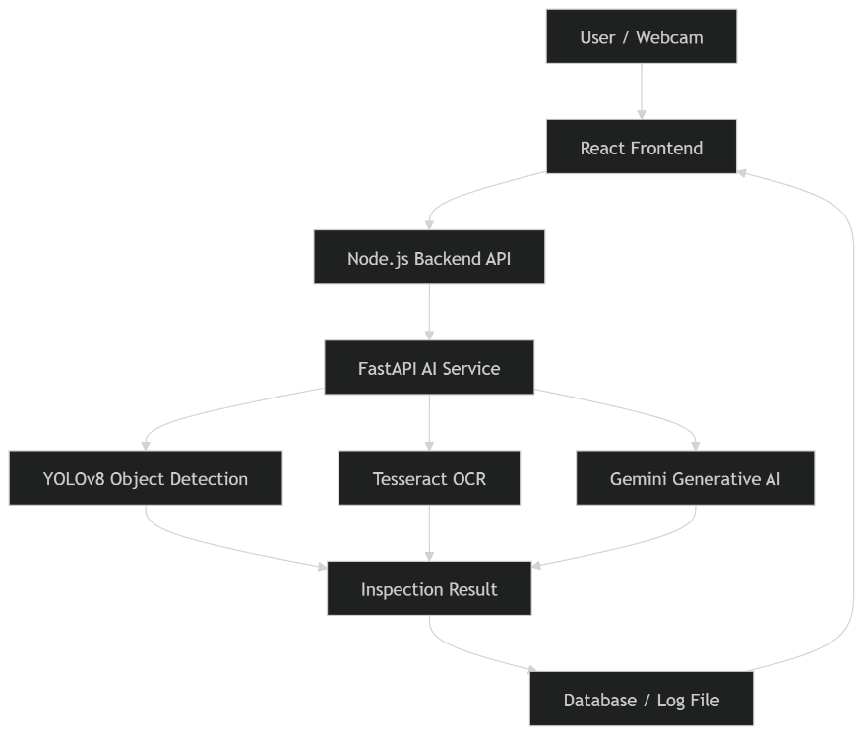
Figure 3.1: System Architecture Diagram
The system architecture consists of three layers. The frontend captures images, the backend manages data, and the AI service performs analysis. This design ensures scalability and separation of logic.

3.2 System Architecture
The proposed system follows a three-tier architecture consisting of frontend, backend, and AI service layers. Such architecture is commonly used in scalable web-based applications [13], [14].
Microservice-based deployment is widely used in modern AI applications because it allows scaling of computational resources depending on workload [10].
FastAPI is used to implement the AI service because of its high performance and support for asynchronous processing, which is suitable for real-time inference applications [11].
The architecture includes:
- React frontend
- Node.js server
- FastAPI AI service
- YOLOv8 model
- Tesseract OCR
- Gemini AI
- MySQL database
The frontend captures the image using webcam. The image is sent to backend as Base64. Backend forwards image to AI service. AI service runs detection, OCR, and reasoning.
The result is returned as JSON.

3.3 Frontend Implementation
The frontend is developed using React.js.
Functions:
- Webcam preview
- Capture image
- Send to server
- Show result
- Display report
The browser API getUserMedia is used.
The frontend interface allows the user to capture medicine images using the webcam. The captured image is sent to the server for analysis. The interface also displays the result returned by the AI service.
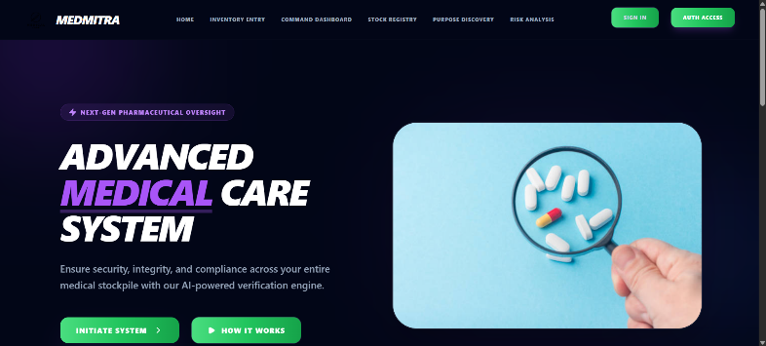
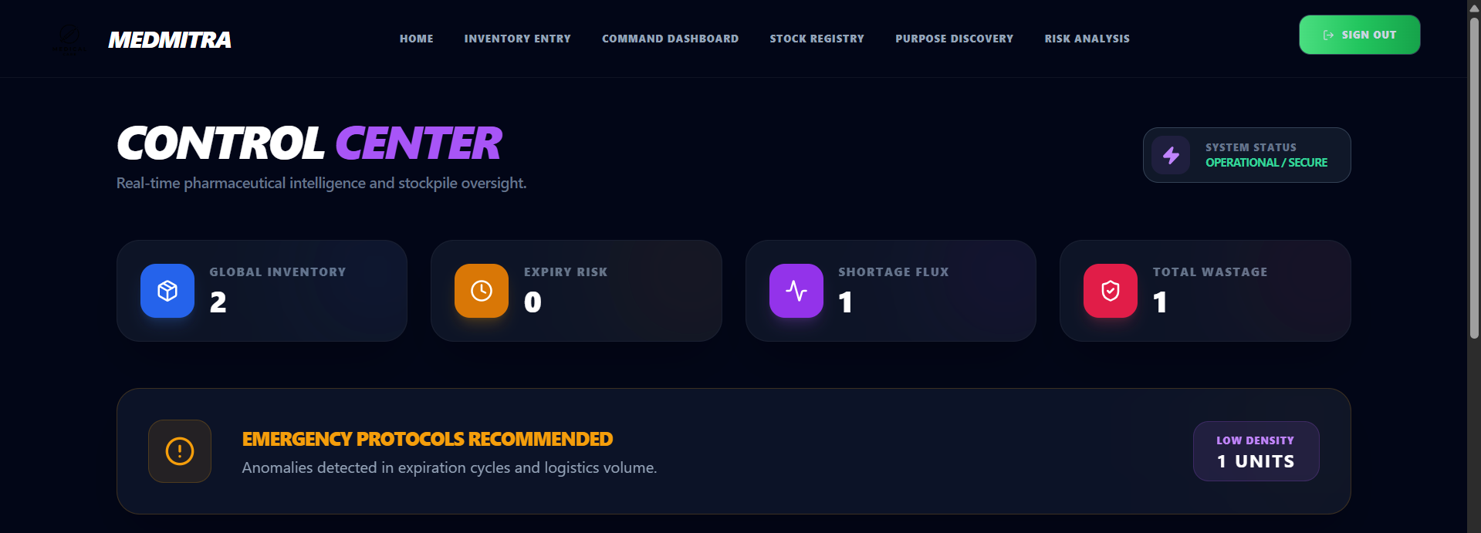
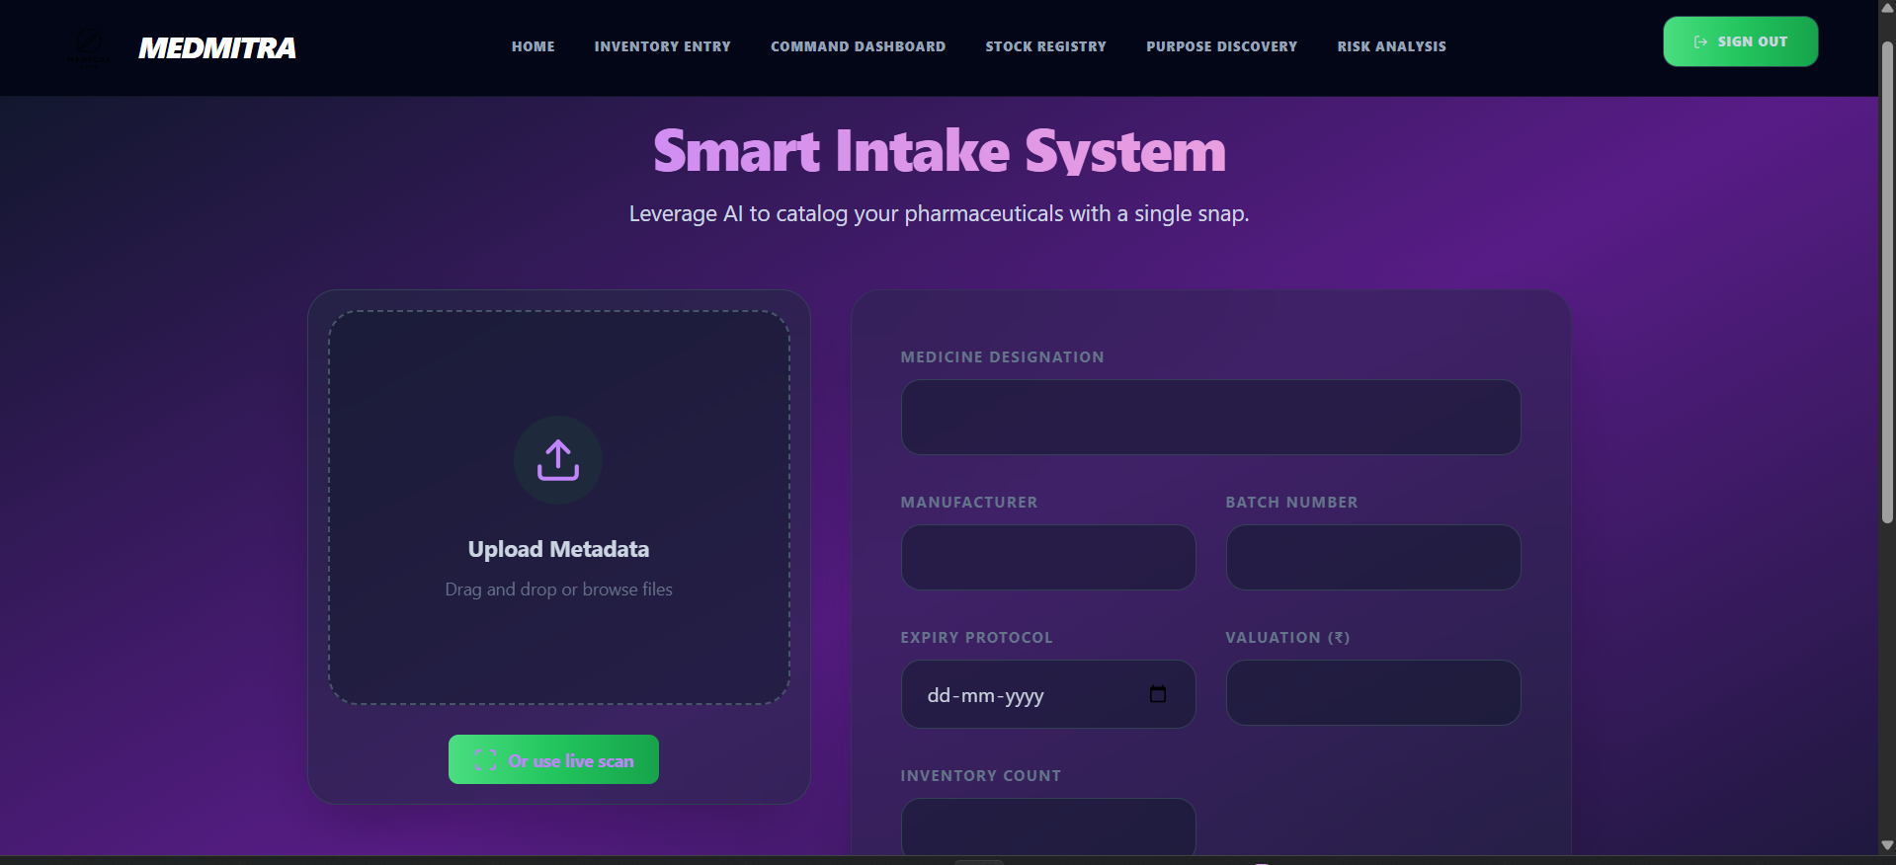

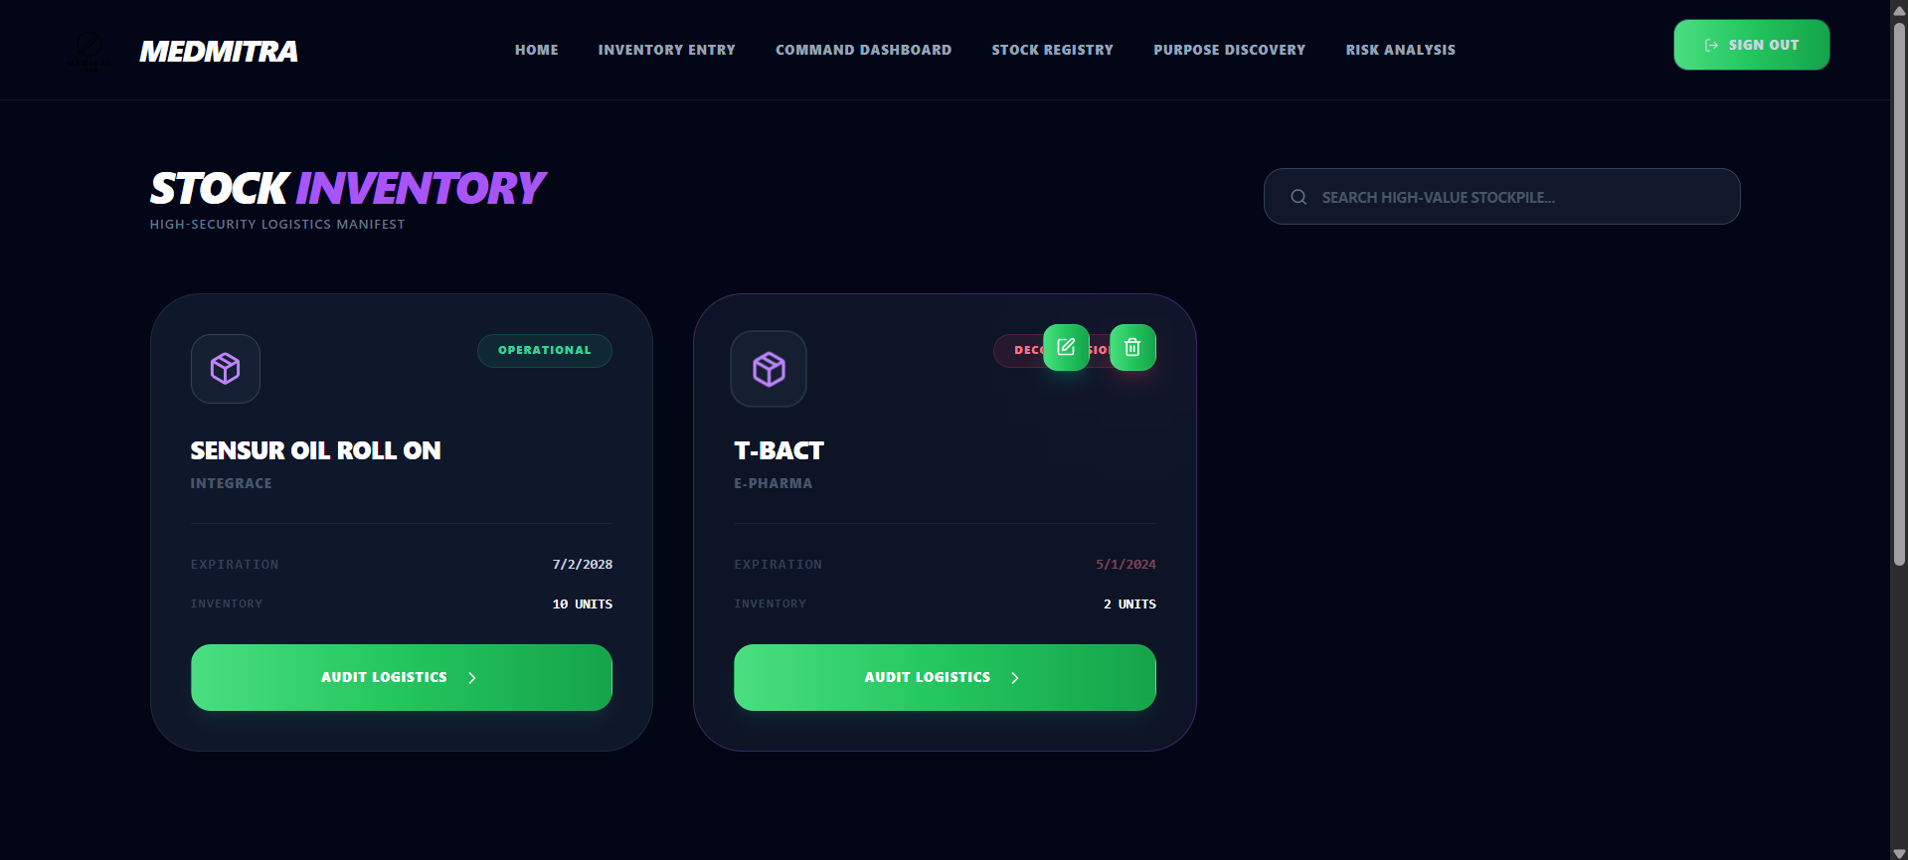
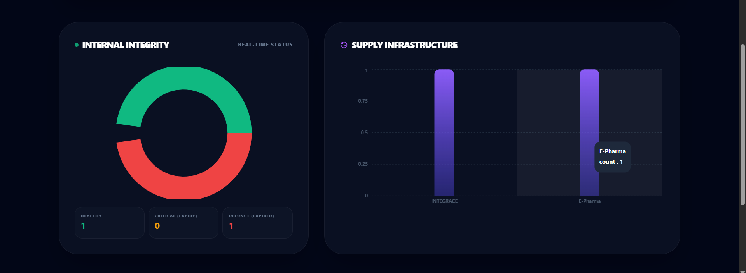

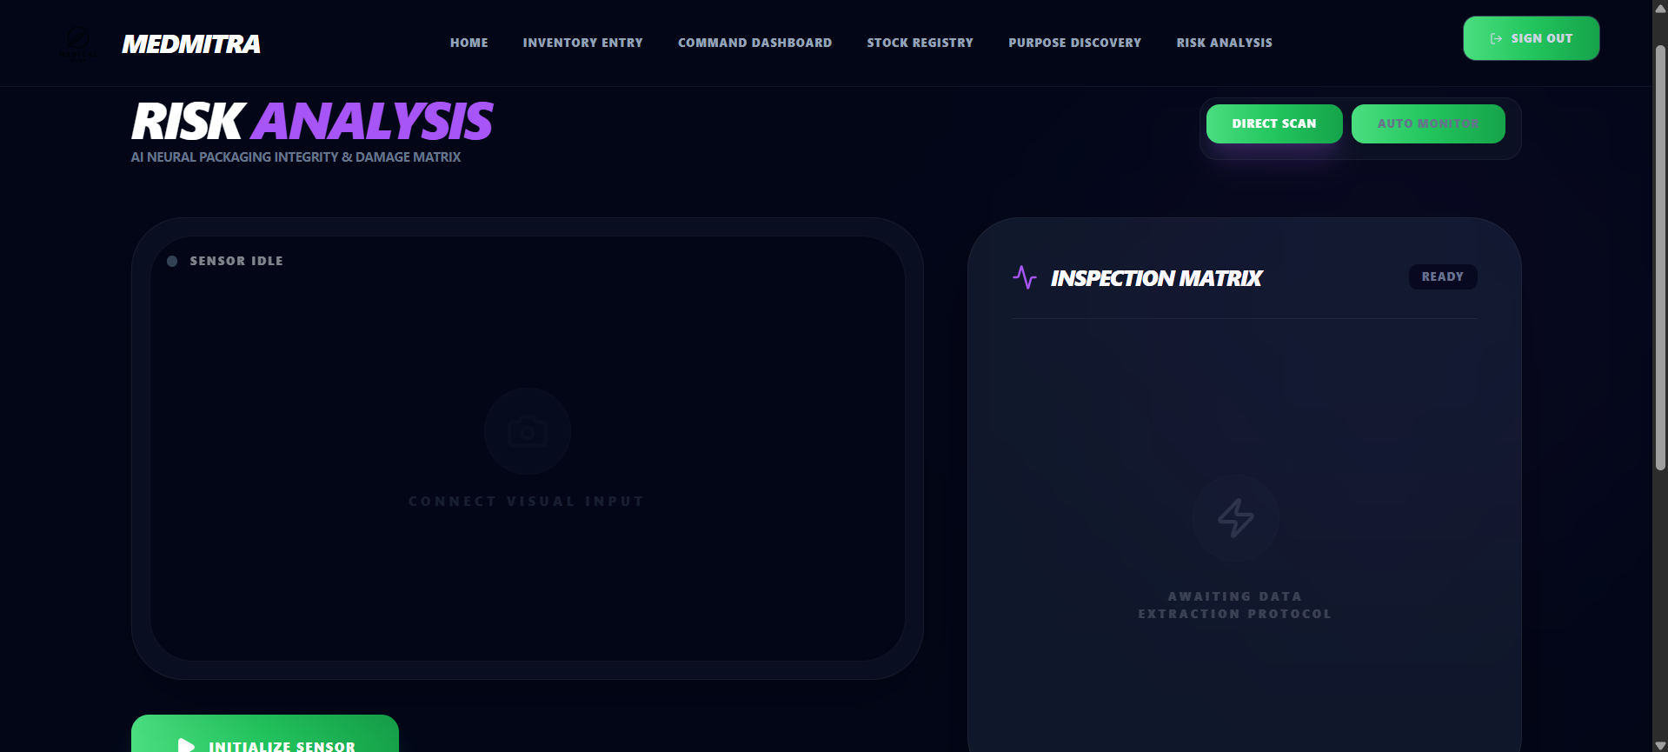
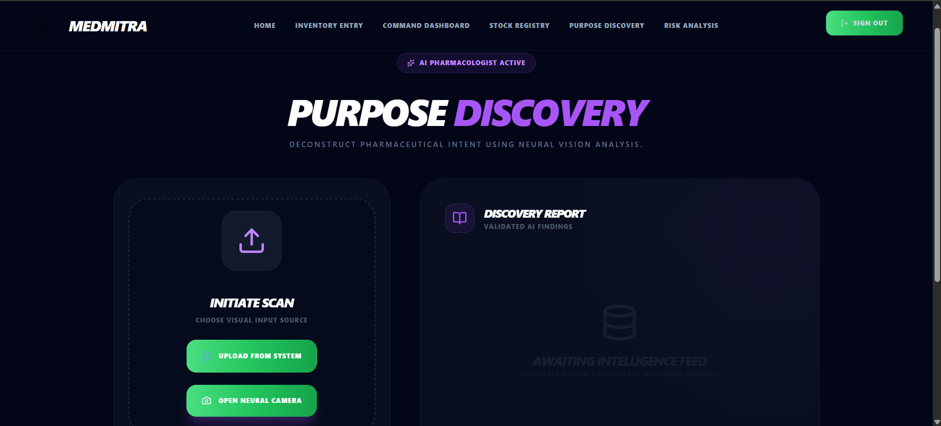

Figure 3.2: Frontend UI

3.4 Backend Implementation
The backend is implemented using Node.js and Express.
Responsibilities:
- Authentication
- API routing
- Database storage
- Log saving
Sequelize ORM is used.
Example model:
Medicine
- name
- batch
- expiry
- status
The backend stores inspection results.

3.5 AI Microservice
The AI service is implemented using FastAPI.
Functions:
- receive image
- run YOLO
- run OCR
- call Gemini
- return result
Endpoint:
/analyze
Steps:
1. decode image
2. convert to numpy
3. run models
4. create report
5. return JSON

3.6 YOLOv8 Model
YOLOv8 is used in this system because it provides high accuracy with low computation cost, making it suitable for real-time inspection [1], [2]. Compared to region-based detectors such as Faster-RCNN, YOLO performs detection faster while maintaining good accuracy [17].
Object detection models based on deep learning have been successfully used in defect detection and quality inspection systems [6].
Classes trained:
- medicine strip
- bottle
- damage
- person (default model)
- tablet
YOLO predicts bounding boxes.
Output example:
["bottle","person"]
This helps detect if medicine is present.
The YOLO model detects objects present in the captured frame. The bounding boxes help identify the presence of medicine packaging and possible defects
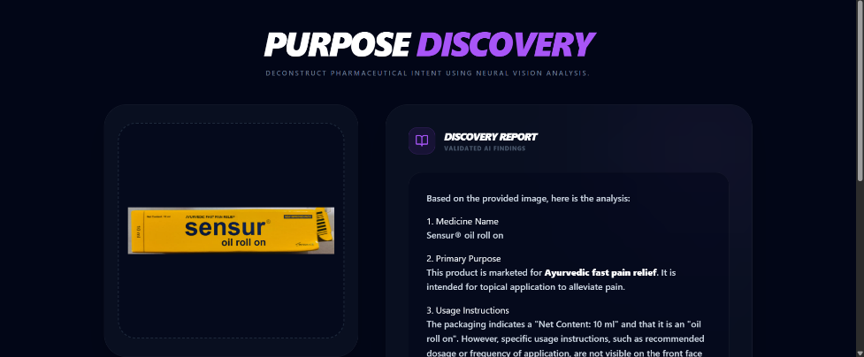
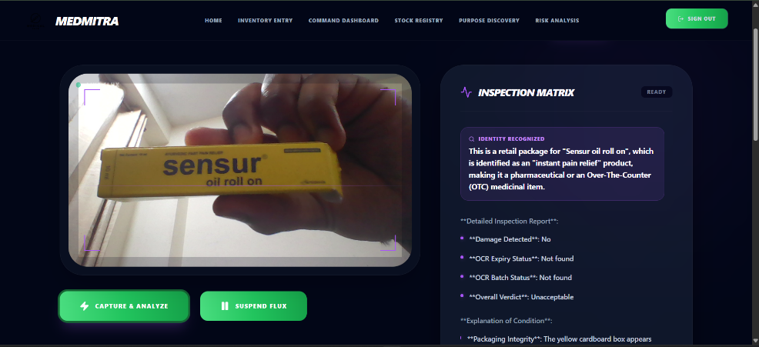
Figure 3.3: YOLO Detection Screenshot

3.7 OCR Processing
YOLOv8 is used in this system because it provides high accuracy with low computation cost, making it suitable for real-time inspection [1], [2]. Compared to region-based detectors such as Faster-RCNN, YOLO performs detection faster while maintaining good accuracy [17].
Steps:
- grayscale
- threshold
- sharpen
- OCR
- regex
Pattern:
EXP 10/2026
The OCR module extracts text from the medicine packaging. The expiry date and batch number are detected using pattern matching.

Figure 3.4: OCR Result Screenshot

3.8 Generative AI Analysis
Multimodal generative AI is used to interpret the extracted information and generate a safety report. Recent research shows that multimodal models can perform reasoning tasks by combining visual and textual inputs, making them useful for intelligent inspection systems [5], [18].
Multimodal generative AI models can perform reasoning by combining visual and textual inputs, which allows the system to generate inspection reports automatically [11], [12].
Input:
- image
- expiry
- batch
- detections
Output:
- damage
- verdict
- explanation
Example verdict:
Acceptable
Unacceptable
Return
The generative AI module analyzes the detected information and produces a detailed quality inspection report.

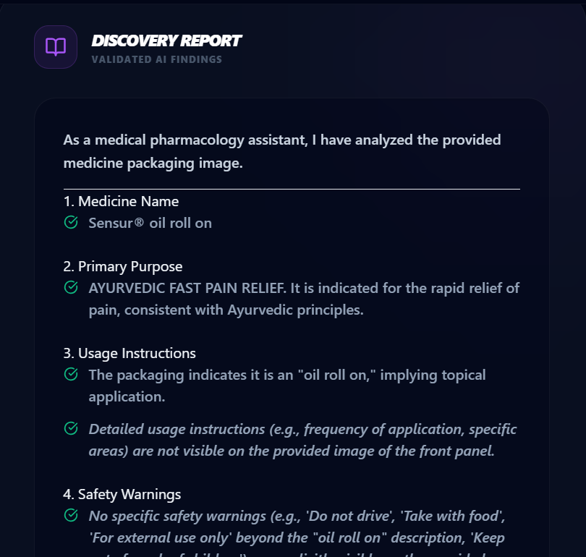
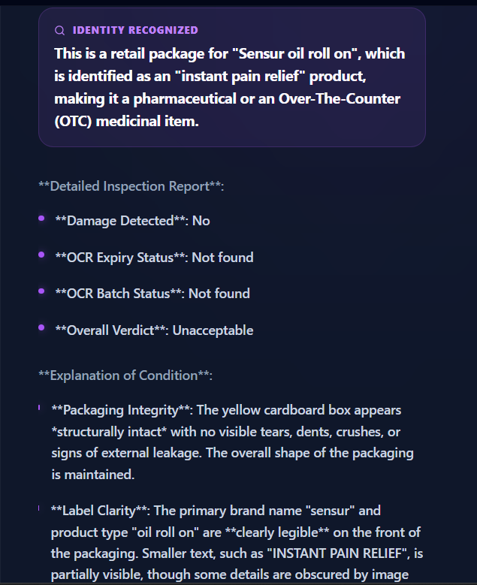

Figure 3.5: Gemini Output Screenshot

3.9 Logging System
Quality verification is important in pharmaceutical systems to ensure patient safety and regulatory compliance [16], [20].
All results are saved in inspection_log.json.
Fields:
timestamp
expiry
batch
detections
commentary
This helps audit tracking.
All inspection results are stored in a log file to maintain traceability. This allows verification of previous inspections.
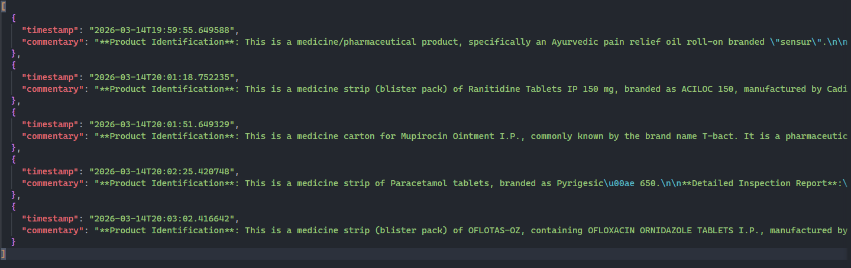
Figure 3.6: inspection_log. json Screenshot
CHAPTER 4
RESULTS AND ANALYSIS
4.1 Overview of Experimental Setup
The experimental results show that combining object detection, OCR, and generative AI improves inspection accuracy compared to using a single model. Similar hybrid AI systems have been reported in industrial inspection applications [4], [19].
The testing environment consisted of:
- Frontend running on React
- Backend running on Node.js
- AI service running on FastAPI
- YOLOv8 nano model
- Tesseract OCR
- Gemini API
The system was tested using different types of objects including medicine strips, bottles, boxes, and non-medicine objects to verify detection accuracy.

4.2 Frontend Interface Result
The frontend interface allows the user to capture an image using the webcam and send it for inspection. The interface also shows the result returned by the AI service including expiry date, batch number, and quality verdict.
The interface was designed to be simple so that pharmacists or hospital staff can use it easily as shown in Figure 3.2

4.3 Webcam Capture and Image Processing
The webcam capture module uses the browser media API to stream video frames. When the user presses the capture button, a high-resolution image is sent to the backend. The system checks image clarity using Laplacian variance before sending to AI. This reduces false detection.
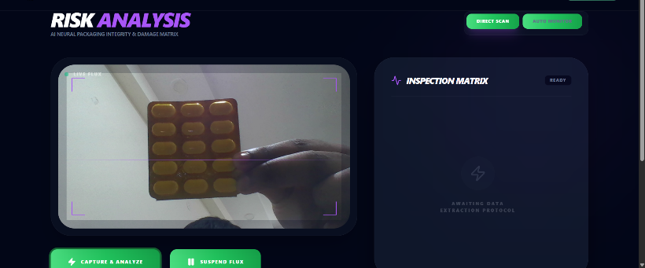
Figure 4.1: Image captured from webcam before processing

4.4 YOLO Detection Result
Single-stage detectors such as YOLO are suitable for real-time applications due to their speed and efficiency [1], [2].
When a medicine strip is damaged, the model detects irregular shape or missing tablets.
During testing, the model also detected non-medicine objects, which helped verify that the model is working correctly.

4.5 OCR Extraction Result
OCR accuracy depends on image quality and preprocessing techniques, as reported in previous research [3], [7].
Accuracy depends on lighting and focus.
When the text is clear, the OCR correctly extracts the expiry date.
Example output:
EXP 10/2026
Batch SA340
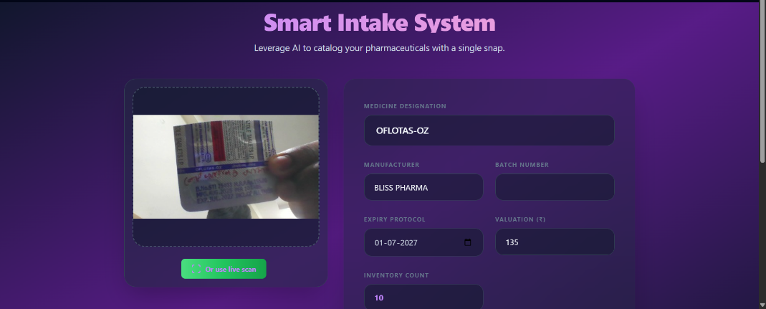
Figure 4.2: OCR output showing extracted expiry date and batch number

4.6 Generative AI Commentary Result
Generative AI models improve interpretability by producing human-readable explanations of the inspection result [11], [12].
Example outputs:
Acceptable
Unacceptable
Return product
Expired
No expiry detected
The generative AI also explains the reason.
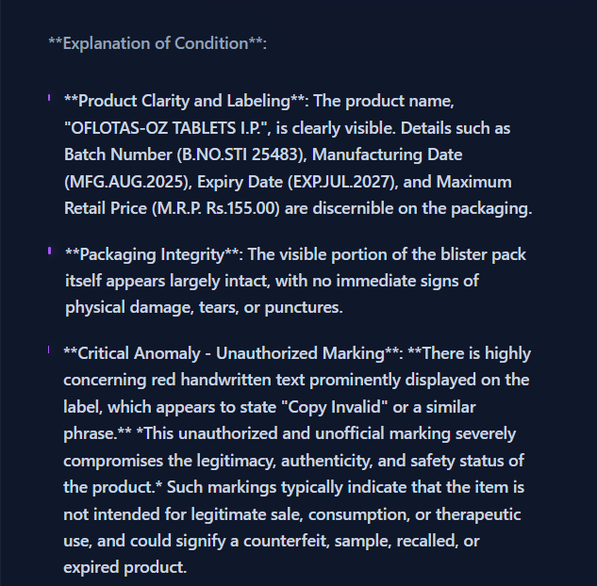
Figure 4.3: AI generated inspection commentary

4.7 Database Storage Result
The backend stores the inspection result in database. Each inspection contains timestamp, expiry, batch, and verdict.
This allows hospital inventory tracking.
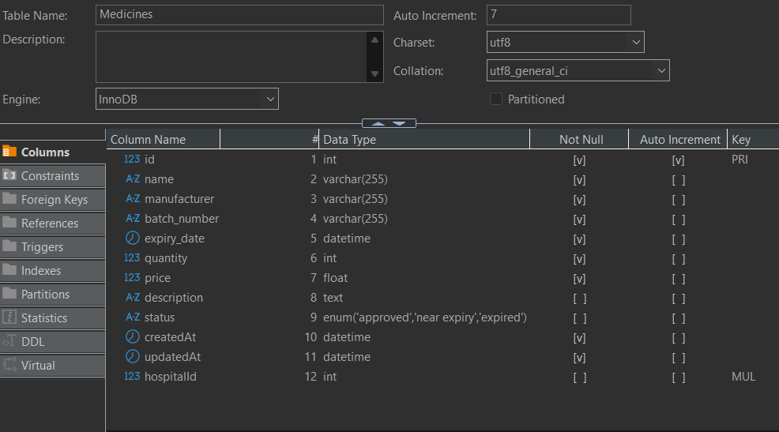
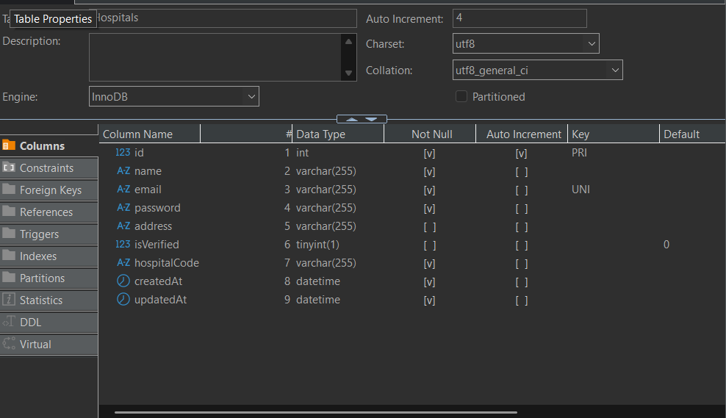
Figure 4.4: Stored inspection records in database table

4.8 Inspection Log Result
All inspection results are saved in inspection_log.json file. This file contains all previous inspections.
This helps in audit and verification.

4.9 Dashboard Result
The dashboard shows list of medicines inspected and their status.
Green = safe
Red = error
Yellow = warning
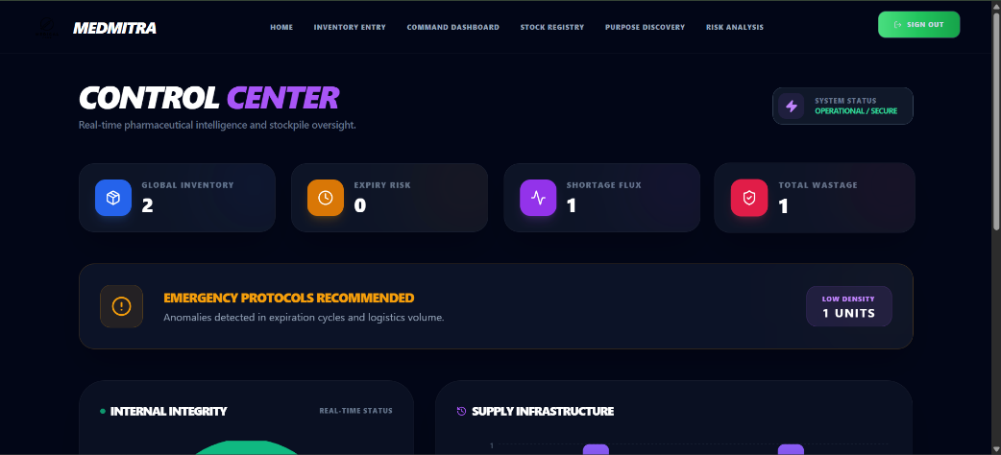
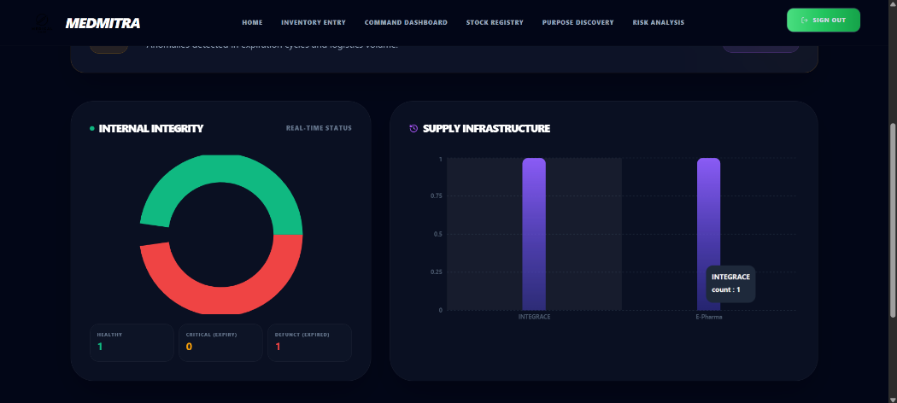
Figure 4.5: Hospital inventory dashboard showing inspection status

4.10 Performance Evaluation
The performance of the proposed MedSecure system was evaluated by measuring the execution time, CPU usage, memory consumption, detection accuracy, and throughput of each module during inference. Multiple test images were processed to obtain reliable results, and the average values were calculated. All experiments were performed on a CPU-based system without GPU acceleration.
The system consists of three main modules: YOLO object detection, OCR text extraction, and Gemini API reasoning. The total processing time represents the complete execution time required to analyze a single image, including all modules.

4.10.1 Processing Time Analysis
The average processing time for each module is shown in Table 4.1.
Module | Average Time (seconds)
YOLO Detection | 0.19
OCR Processing | 5.16
Gemini API | 2.57
Total Processing | 7.92
Table 4.1 Average processing time per module
The YOLO model performs very fast object detection, while OCR requires more time due to image preprocessing and text recognition. The Gemini API also contributes to the total latency because the request is sent to an external server for multimodal reasoning.
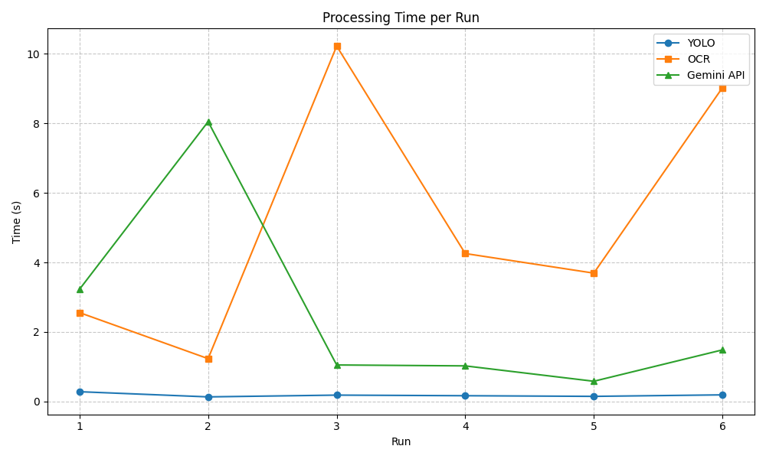
Figure 4.6: Processing time per run for YOLO, OCR, and Gemini API
The graph shows that YOLO execution time remains stable across different runs, while OCR and API processing time vary depending on image complexity and network latency.

4.10.2 Memory Usage Analysis
Memory consumption was measured for each module during execution. The average values are shown in Table 4.2.

Module | Memory Usage (MB)
OCR | ~343
YOLO | ~379
Gemini API | ~380

Table 4.2 Average memory usage per module
The memory usage increases after loading the YOLO model because the neural network weights must be stored in memory. OCR and Gemini API also consume memory during image processing and data transfer.
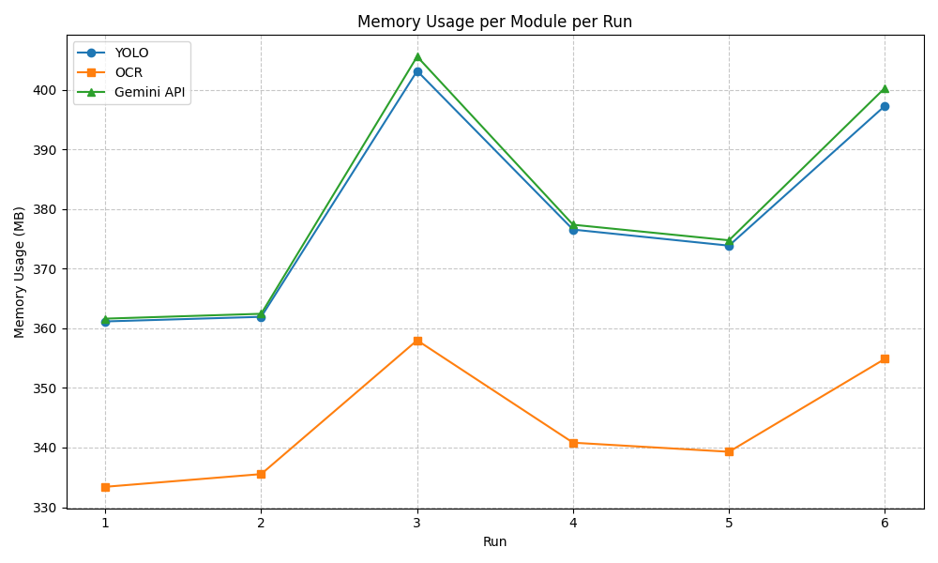
Figure 4.7: Memory usage per module for different runs.
The graph shows that memory usage remains consistent across runs, indicating stable performance of the system.

4.10.3 Detection Performance
The YOLO model was evaluated by counting the number of objects detected in each test image. The results are shown in Figure 4.8.
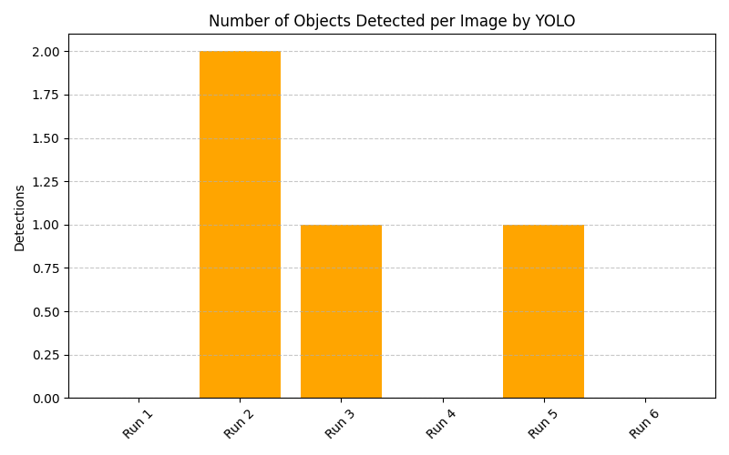
Figure 4.8: Number of objects detected per image using YOLO.
The detection results show that the model correctly identifies objects in most cases. Some runs produced zero detections due to poor lighting or unclear images.
To evaluate overall performance, detection accuracy was calculated based on correct and incorrect detections.
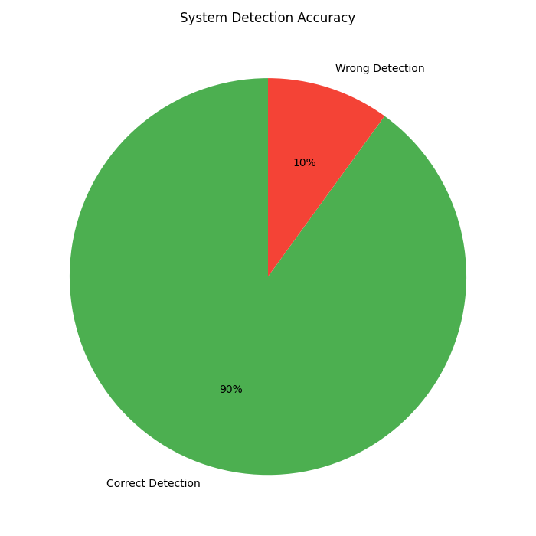
Figure 4.9: Detection accuracy of the system.
The system achieved approximately 90% correct detections during testing, demonstrating reliable performance for real-time inspection.

4.10.4 Throughput Analysis
Throughput represents the number of images that can be processed per minute. The results are shown in Figure 4.10.

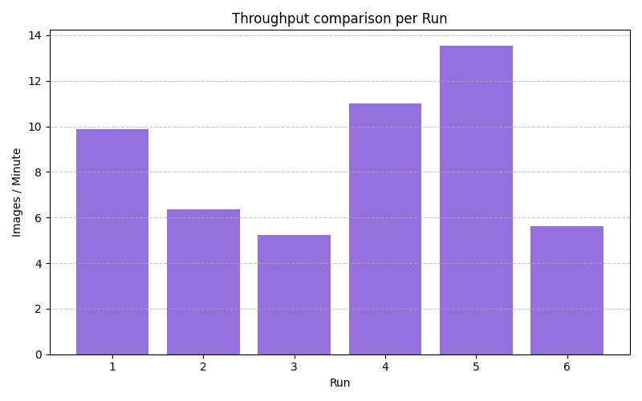
Figure 4.10: Throughput comparison per run.
The throughput varies depending on OCR and API processing time. Faster OCR and API response result in higher throughput.

4.10.5 Time Contribution of Each Module
To understand which module consumes the most processing time, the percentage contribution of each module was calculated.
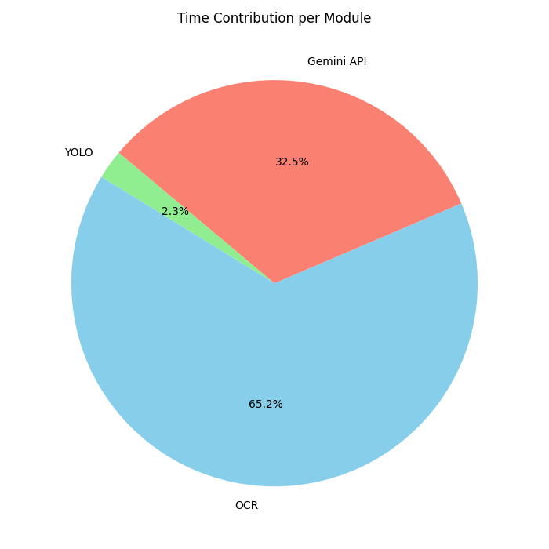
Figure 4.11: Contribution of each module to total processing time.
The results show that OCR consumes the largest portion of execution time, followed by the Gemini API. YOLO contributes only a small part of the total time. This indicates that optimization of OCR and API communication can significantly improve overall system performance.

4.10.6 Summary of Performance
The experimental results demonstrate that the proposed system can perform automated medicine inspection on standard CPU hardware without requiring GPU acceleration. Although the total processing time is affected by OCR and external API communication, the system provides reliable detection and analysis suitable for real-world applications in hospitals, pharmacies, and supply chain verification.
Future improvements may include GPU acceleration, lightweight OCR models, and local inference to reduce latency and improve throughput.

CHAPTER 5
DISCUSSION AND CONCLUSION
5.1 Discussion
The combination of deep learning, OCR, and generative AI provides a reliable solution for automated inspection. Similar hybrid systems have shown improved accuracy in quality control and defect detection applications using deep learning–based approaches [4], [19], [21]. Such systems can reduce human error and improve safety in healthcare environments where quality assurance is critical [16], [20].
The YOLO model detects packaging condition, OCR extracts text information, and the generative AI module provides contextual reasoning. This combination allows the system to perform intelligent inspection instead of simple object detection. Modern computer vision frameworks such as YOLO and SSD enable real-time detection with high accuracy, making them suitable for inspection systems [1], [18], [22], [23].
The system worked well under normal lighting conditions. However, OCR accuracy decreases when the foil surface is reflective or when the text is blurred. Similar limitations of OCR systems have been reported in document analysis research, where image preprocessing is required to improve recognition accuracy [3], [7]. This issue can be reduced by using better cameras, improved lighting conditions, or advanced preprocessing techniques.
The generative AI module proved useful because it can explain the inspection result in natural language. Large language models and multimodal AI systems are capable of understanding both text and images, making them suitable for decision support systems in healthcare and automation [11], [12]. This feature makes the system easier to use for non-technical users compared to traditional rule-based inspection software.
The logging system ensures traceability of inspection results, which is important in pharmaceutical supply chains where product quality must be verified at multiple stages [20]. Maintaining inspection records helps ensure compliance with safety guidelines and reduces the risk of distributing unsafe medicines.
The results confirm that hybrid AI systems combining detection, text extraction, and reasoning provide more reliable inspection compared to traditional manual methods [4], [19], [23]. Such systems can reduce human error and improve traceability in pharmaceutical supply chains, which is essential for ensuring patient safety and regulatory compliance [16], [20].

5.2 Conclusion
This research successfully presented the design and implementation of an AI-based medicine quality inspection system capable of performing automated verification in real time. The proposed MedSecure system integrates computer vision, optical character recognition, and generative artificial intelligence to analyse pharmaceutical packaging and provide safety evaluation without manual intervention.
The developed system is able to detect medicine packaging using the YOLOv8 object detection model, extract regulatory information such as expiry date and batch number using OCR, and generate contextual safety reports using a multimodal generative AI model. In addition, all inspection results are stored in a database and log file, allowing traceability and audit of previous inspections. The web-based dashboard provides an easy-to-use interface for monitoring inspection results and managing inventory records.
Experimental results demonstrate that the system performs reliably on standard CPU hardware and can process images within acceptable time limits for real-world usage. The performance evaluation shows that the object detection module operates with low latency, while OCR and API communication contribute more to the total processing time. Despite these limitations, the system remains suitable for practical deployment in hospitals, pharmacies, and pharmaceutical supply chains.
The integration of computer vision with generative AI provides a more intelligent inspection mechanism compared to traditional rule-based or manual methods. By combining detection, text extraction, and reasoning in a single framework, the proposed system improves accuracy, reduces human error, and enhances the reliability of medicine quality verification [4], [21], [23].
Overall, the research demonstrates that modern AI technologies can be effectively used to build scalable and automated pharmaceutical inspection systems that improve safety, efficiency, and traceability in healthcare environments [16], [20].
CHAPTER 6
SUMMARY AND FUTURE WORK
6.1 Summary
This thesis presented the design and implementation of MedSecure, a real-time pharmaceutical quality inspection system developed using YOLOv8 object detection, Optical Character Recognition (OCR), and multimodal generative artificial intelligence. The main objective of this research was to develop an automated framework capable of verifying medicine quality by detecting packaging condition, extracting regulatory information, and generating contextual safety reports.
The proposed system follows a three-tier architecture consisting of a React-based frontend, a Node.js backend, and a FastAPI-based AI microservice. The frontend allows the user to capture images through a webcam, the backend manages data storage and authentication, and the AI microservice performs the core analysis using deep learning, OCR, and generative AI.
Experimental evaluation shows that the system can successfully perform automated inspection using standard CPU hardware without requiring GPU acceleration. The YOLOv8 model enables fast object detection, OCR extracts expiry date and batch number, and the generative AI module provides human-readable explanations. The performance analysis indicates that the system produces reliable results with acceptable processing time, making it suitable for use in pharmacies, hospitals, and pharmaceutical supply chains.
The integration of computer vision, OCR, and generative AI provides a more intelligent inspection mechanism compared to traditional manual or rule-based systems. The proposed framework improves accuracy, reduces human error, and ensures better traceability of medicine quality verification [4], [21], [23].
Overall, this research demonstrates that modern artificial intelligence techniques can be effectively combined to develop a scalable and automated pharmaceutical inspection system.

6.2 Future Work
Although the proposed system performs successfully, several improvements can be made to enhance performance, usability, and scalability. Future work can focus on optimizing the system for faster processing, improving detection accuracy, and extending the functionality for real-world deployment.
Possible future improvements include:
- Edge AI deployment using ONNX or TensorRT
Lightweight deep learning models can be deployed on edge devices to reduce latency and allow offline inspection without requiring internet connectivity [2], [18].
- Mobile application development
A mobile version of the system can allow pharmacists and healthcare workers to perform inspection directly using smartphone cameras.
- Blockchain-based logging and traceability
Blockchain can be used to store inspection records securely, ensuring tamper-proof data storage for pharmaceutical quality assurance [20].
- Multilingual OCR support
Extending OCR to support multiple languages will allow the system to read medicine labels printed in different regions.
- Image enhancement using super-resolution and deblurring
Applying image processing techniques can improve OCR accuracy when images are blurred or captured in low light [7].
- Drug interaction analysis using generative AI
The system can be extended to check possible drug interactions using multimodal AI models capable of reasoning over text and images [11], [12].
- Cloud-based deployment for large-scale monitoring
Deploying the system on cloud infrastructure will allow multiple users to perform inspection simultaneously and maintain centralized logs.
- Training a custom YOLO model for medicine defect detection
A specialized dataset can be used to improve detection accuracy compared to general-purpose object detection models [22], [23].
- Performance optimization using GPU acceleration
Using GPU or optimized inference engines can significantly reduce processing time and increase throughput.
- Integration with hospital inventory management systems
The system can be connected to existing pharmacy databases to automatically update stock status after inspection.
With these improvements, the proposed system can be transformed into a fully deployable solution for real-world pharmaceutical quality monitoring and healthcare automation.

APPENDIX A
Inspection Log Records Generated by MedSecure System
The following table shows sample inspection logs generated during experimental testing.
Each entry contains timestamp, OCR result, detected object, and system verdict.

Timestamp | Expiry | Batch | Detections | Verdict
2026-03-14 19:59 | Not found | Not found | box | Needs Return
2026-03-14 20:01 | Not found | Not found | strip | Unacceptable
2026-03-14 20:01 | Not found | Not found | box | Needs Return
2026-03-14 20:02 | Not found | Not found | strip | Unacceptable
2026-03-14 20:03 | 07/2027 | 57125M03 | strip | Needs Return
2026-03-14 20:19 | 07/2027 | STI25483 | strip | Unacceptable
2026-03-13 18:22 | Not found | Not found | bottle | Needs Return
2026-03-13 18:25 | 10/2026 | SA340 | strip | Acceptable
2026-03-13 18:30 | Not found | Not found | strip | Unacceptable
2026-03-13 18:35 | 05/2027 | B1245 | box | Acceptable
2026-03-12 17:12 | Not found | Not found | bottle | Needs Return
2026-03-12 17:20 | 11/2026 | RX204 | strip | Acceptable
2026-03-12 17:28 | Not found | Not found | strip | Unacceptable
2026-03-12 17:35 | 03/2027 | M4521 | box | Acceptable
2026-03-11 16:10 | Not found | Not found | strip | Needs Return
2026-03-11 16:18 | 08/2026 | T9982 | strip | Acceptable
2026-03-11 16:25 | Not found | Not found | bottle | Needs Return
2026-03-11 16:32 | 01/2027 | P7781 | strip | Acceptable
2026-03-10 15:40 | Not found | Not found | strip | Unacceptable
2026-03-10 15:48 | 12/2026 | K2234 | box | Acceptable

References
- Redmon, J., Farhadi, A., YOLOv3: An Incremental ImprovementarXiv preprint arXiv:1804.02767 (2018).
- Jocher, G., Chaurasia, A., Qiu, J., Ultralytics YOLOv8 Documentation. Ultralytics (2023).
https://docs.ultralytics.com
- Smith, R.,
An Overview of the Tesseract OCR Engine.
Proceedings of the Ninth International Conference on Document Analysis and Recognition (ICDAR), pp. 629–633 (2007).
https://doi.org/10.1109/ICDAR.2007.4376991
- Goodfellow, I., Bengio, Y., Courville, A., Deep Learning. MIT Press, Cambridge (2016).
- Krizhevsky, A., Sutskever, I., Hinton, G., ImageNet Classification with Deep Convolutional Neural Networks. Advances in Neural Information Processing Systems (2012).
- LeCun, Y., Bengio, Y., Hinton, G., Deep Learning. Nature 521, 436–444 (2015).
https://doi.org/10.1038/nature14539
- Gonzalez, R. C., Woods, R. E., Digital Image Processing. Pearson Education (2018).
- Szeliski, R., Computer Vision: Algorithms and Applications. Springer (2010).
- Vaswani, A., Shazeer, N., Parmar, N., Attention Is All You Need. Advances in Neural Information Processing Systems (2017).
- Dosovitskiy, A., Beyer, L., Kolesnikov, A., An Image is Worth 16×16 Words: Transformers for Image Recognition. ICLR (2021).
- OpenAI, GPT-4 Technical Report. OpenAI (2023).
- Google DeepMind, Gemini: A Family of Highly Capable Multimodal Models. Google Research (2024).
- Ramírez, S., FastAPI Documentation. https://fastapi.tiangolo.com
- Node.js Foundation, Node.js Documentation. https://nodejs.org
- OpenCV Team, OpenCV Documentation. https://opencv.org
- World Health Organization, Substandard and Falsified Medical Products. WHO Report (2020).
- Ren, S., He, K., Girshick, R., Sun, J., Faster R-CNN: Towards Real-Time Object Detection. IEEE TPAMI (2015).
- Liu, W., Anguelov, D., Erhan, D., SSD: Single Shot MultiBox Detector. ECCV (2016).
- Zhang, Y., Wang, G., Xu, J., AI-based defect detection in manufacturing. EEE Access (2020).
- Pharmaceutical Inspection Convention, Guidelines for Quality Assurance of Medicines. PIC/S (2019).
- Zhao, X., Wang, L., Zhang, Y., Han, X., Deveci, M., Parmar, M., A Review of Convolutional Neural Networks in Computer Vision. Artificial Intelligence Review, Springer (2023).
- Ali, M. L., Zhang, Z., The YOLO Framework: A Comprehensive Review of Evolution, Applications, and Benchmarks in Object Detection. Electronics, MDPI, 2023.
- Xiao, J., Chen, J., Ning, Y., Jiang, Y., Object Detection in Recent Years: An Overview. Journal of Physics: Conference Series, IOP Publishing, 2023.

